
Maddiston Primary School

Primary One Induction Handbook for parents
We learn together,
We have fun together,
We succeed together,
We shine brightly.

Welcome

We wish a very warm welcome to all of our boys and girls and to their families.

You may be aware that transition activities are available on the school website https://www.maddiston.falkirk.sch.uk under the section “school life” – “transition to primary one”. This page has a wealth of information including a virtual tour and a Sway presentation.

Please don’t worry if there are skills your child doesn’t yet have. Your child is at the heart of everything we do. Every child within Maddiston Primary School is valued and will be treated as an individual within our safe, nurturing and supportive environment.
We hope that this information booklet helps you to feel informed and gives you some practical information about how you can help your child settle into primary one.

We look forward to welcoming you and your child into our school community.

Parents as Partners

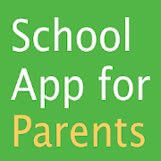
One of the main ways the school communicates is through the School App for parents. Please download the app onto your device for all the information regarding the school calendar dates, messages and news.

Follow us on our Primary 1 Twitter Account: MPS_Primary1 for P1B and P1C and MpsPrimary for P2/1

Log onto our website https://www.maddiston.falkirk.sch.uk

Call the school on 01324 506750

E-mail the school: maddistonprimaryschool@falkirk.gov.uk

Getting Involved

- help your child with homework
- become a parent helper
- join the Parent Council
- join the PSA
- volunteer to help on school trips and special events
- attend parents’ evenings, workshops, learning cafes, open library events and the many more events we have within the school

Meet the Maddiston Senior Management Team

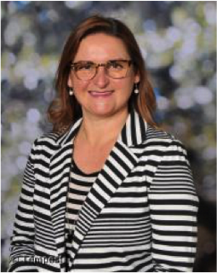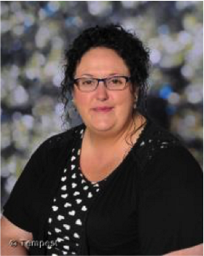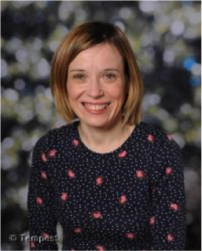
Depute headteacher (Timezone):
Mrs Watson
Depute headteacher: Mrs Chalmers

Headteacher:
Mrs McGlynn

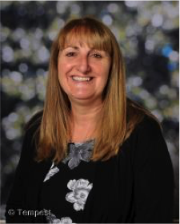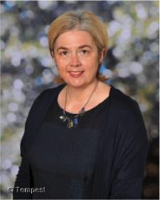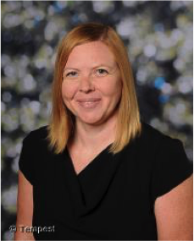
Principal Teachers
Mrs Russell
Mrs Westwood
Mrs Woodburn

The senior management team are very much involved in the life of the school. As part of their leadership responsibilities, they offer pastoral support for the children.

Meet the primary one teachers

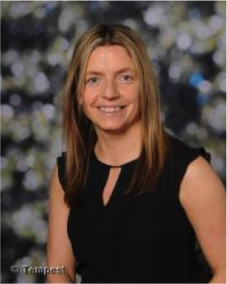

Miss Taylor – P1T
Mrs Byrne – P1B

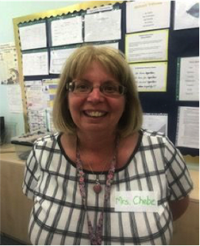

Mrs Chebe– P2/1

School uniform
Please dress your child in uniform every day. This helps everyone to feel part of our school community.
Our school uniform:
- Black trousers or skirt - a tartan skirt is also available
- Yellow polo shirt
- Black sweatshirt with school badge
- Black school shoes
- White shirt and school tie (yellow and black)



Please put your child’s name on all items of clothing, gym bags, school bags and packed lunch boxes.
Our embroidered uniform can be purchased from BE School Wear, 32 Vicar Street, Falkirk, FK1 1JB or online www.border-embroideries.co.uk

Physical Education
Your child is entitled to two hours of P.E per week. Teachers will communicate with you to tell you when your child will need their PE kit. The appropriate clothing and footwear for PE is a T-shirt, shorts and gym shoes with non-marking soles. These should be kept in school and kept together in a drawstring bag with all items labelled with your child's name, including their shoes. PE lessons may also take place outside and children will need to dress appropriately for outdoors. Outdoor kit would include outdoor trainers, sweater, jogging bottoms and a t-shirt/sweater. Any jewellery must be removed for PE classes and long hair should be tied back.

Reporting Absence
- If your child is not attending school, you must phone the school by 9.30am to let the school know the reasons for the absence.
- You must repeat this process if your child is not in the next day.
- When your child returns to school, please provide a note explaining their absence.
- If you do not follow this process, letters may be sent home which highlights concerns over attendance. This is in line with school and authority policy.
What if my child becomes ill during the day?
- We will contact you (or your emergency contact) as soon as possible and your child will be cared for until you arrive.

School lunches
All children are entitled to a free school meal. They can have a hot dinner, a pick and mix or bring a packed lunch. It is essential that names are clearly marked on packed lunch boxes.
The school app will provide you of a daily reminder of what is being served each day and the school menus are available on the Falkirk Council website. If your child requires a medically prescribed diet, please ensure that you have completed a prescribed diet declaration form (available from the school office) and hand it back to the school office. Without the completed form, the kitchen will be unable to make any changes to the standard menu.
Pupils should not bring cans or glass bottles. All pupils are encouraged to finish their lunch within the dinner hall.
Children going home for lunch should be collected from the main reception.
Please only put into the lunch box what your child would usually eat at home. If they are faced with lots of food, children can sometimes become overwhelmed.
Meals should be ordered for the week using the I-pay system. If children are going home or having a packed lunch, this should also be marked on the I-pay system. When your child starts school, you will be given a unique reference number and information on how you can Register for iPayimpact. For the first few days, your child’s teacher will support them in making their choices for lunch.

Playtime
- Children go out to play mid-morning and at lunch time, so it is important that they are suitably dressed. When the weather is unsuitable for outdoor play, the children are supervised in their classroom by support staff and senior pupils.
- Every day at 10.20am, the children come together to eat their snack. Sometimes the children share some of the activities they have engaged in with the class, sometimes they will share a story together and other times the children are encouraged to sit with friends and build social relationships. We encourage a healthy snack such as fruit. Please do not send more than one snack for your child, as there is simply not enough time for them to eat it. One small snack is enough before they eat lunch around midday.

- Playground supervision is available during the playtime and lunch hour.
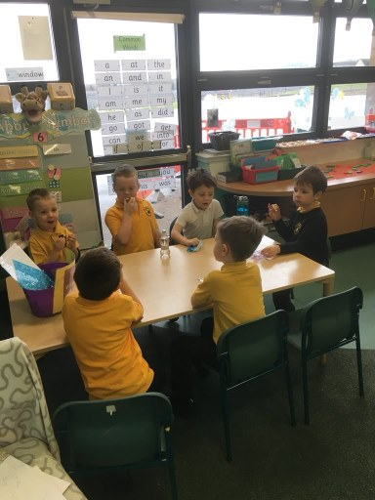
- Minor accidents do happen and the school has a number of staff who are trained in first aid. If your child has a fall or bump, they will be treated in the first aid room and your child will be given a slip giving details about the accident and/or any treatment. You will be contacted if the accident is of a more serious nature. If you are unavailable, we will contact the person identified as an emergency contact. Please make sure the school always have updated contact details if these change. On the rare occasion that your child may need a change of clothes, a support member of staff will help to change them. It would be much appreciated if these clothes could be washed and returned as soon as possible.

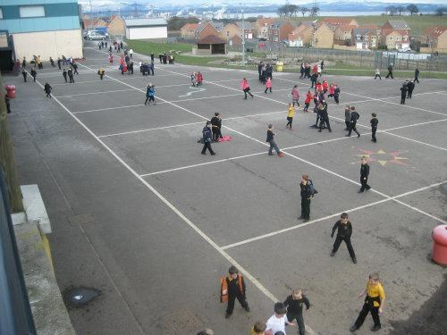

Before and after school
- Breakfast club is normally available at a cost of £1.75 per child and is held in the dinner hall. Breakfast club normally starts at 8.30am (this is subject to change). Children should not be dropped off any earlier than this time as there will be no access to the school building until then.
- Primary 1 children will line up at the door to the left of the main entrance. Arrangements for the children’s first day of school are included in your pack.
- Please share with your children what the arrangements are for pick-up at the end of the day. If there are any changes to these arrangements, please contact the school office to let us know. Please let the school know if there is anyone your child must not go home with and let the class teacher or the office know if there will be someone different picking your child up at the end of the day.

- At the end of the day, the Primary 1 teacher will take the children to the door and check that there is someone to take them home. Children must wait beside the teacher until they can see the person collecting them. It is helpful if you reinforce this message at home.

- There is normally an after school club for children. This is run through First4kids. You must write a note to your child’s teacher to let the school know any days that your child will be attending the after school club. If you wish to contact them for further information regarding their service, please follow this link - http://www.first4kids.org/Contact/

- Please don’t worry if your child doesn’t tell you anything about their day. Some children like to talk about their day at school and others will not share a great deal.

- Your child can bring their bike or scooter to school and lock these in the parking bays. However, for safety reasons, we ask the children not to use their bikes or scooters in the playground.
- In extreme weather, children will be brought into school 5 minutes before their start time.

Curriculum
Scottish schools follow the Curriculum for Excellence.
Its purpose is aimed to help children to become:
- Successful learners
- Confident individuals
- Responsible citizens
- Effective contributors
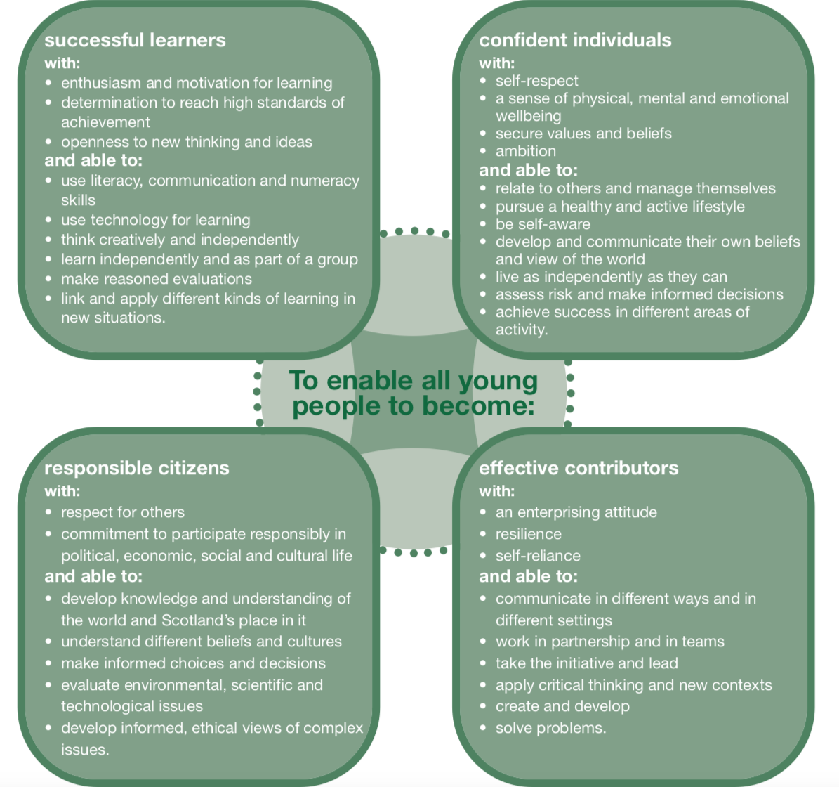
Further information about the curriculum is under section three in the school handbook, which can be downloaded from the school website.

The curriculum develops skills for learning, life and work, bringing real life into the classroom, making learning relevant and helping young people apply lessons to their life beyond the classroom. It links knowledge in one subject area to another helping make connections in learning. It develops skills which can enable children to think for themselves, make sound judgements, challenge, enquire and find solutions. Our curriculum map provides an overview of how our curriculum is delivered at Maddiston Primary School.
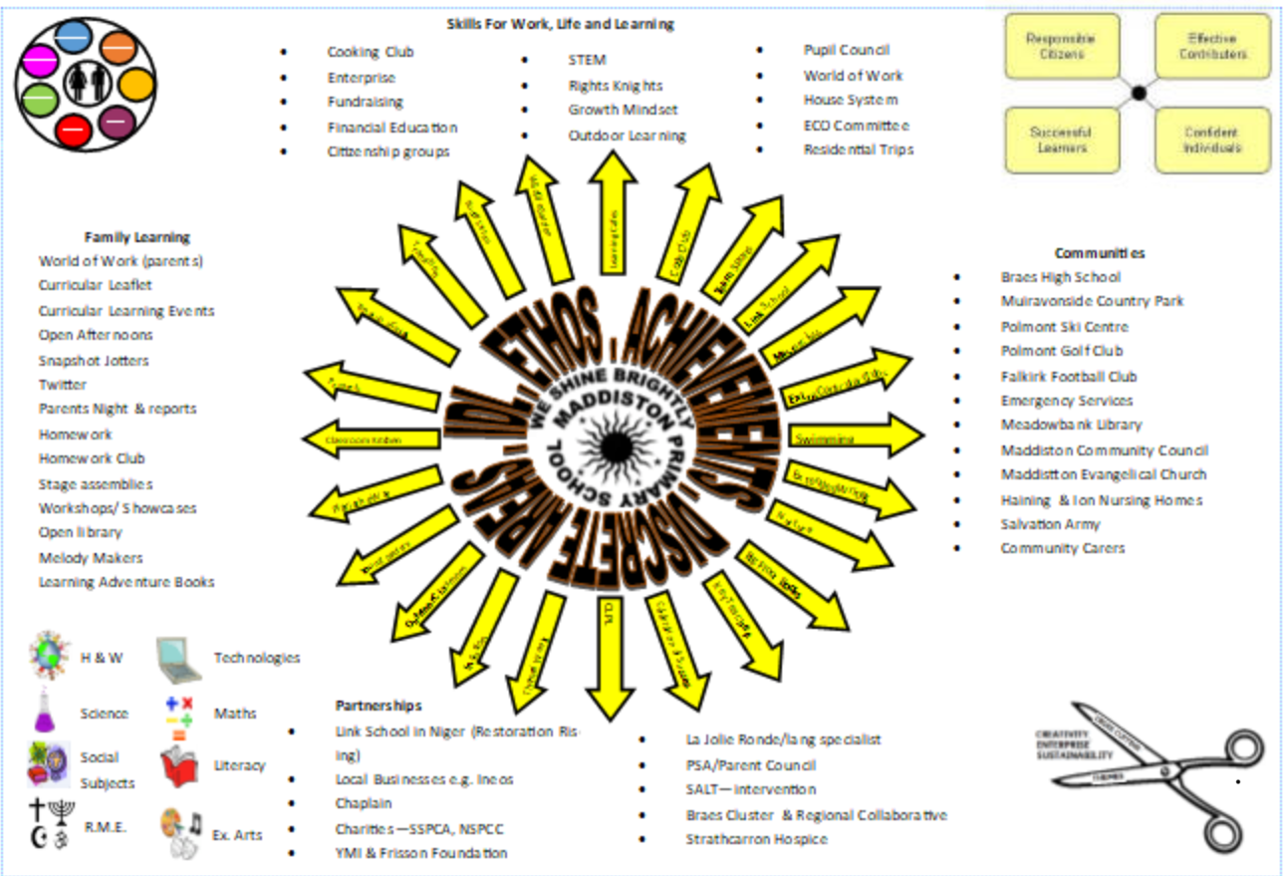
There are eight curriculum areas through which your child will learn and develop. These areas are Expressive Arts, Health & Wellbeing, Language & Literacy, Numeracy & Mathematics, Technologies, Social Studies, Sciences, Religious and Moral Education.

Key literacy and numeracy in primary one
Some of the things children will learn:

Maths  - to recognise numerals, shapes and money  - to recognise numicon shapes and patterns  - to sort  - to count objects  - about charts and graphs  - about ordering  - addition facts  - subtraction facts  - numbers within 100 | Reading  - to recognise letter shapes and sounds  - to recognise key words  - to read within a group  - to build and decode simple words  - to say the alphabet  - about reading conventions  - to ask and answer questions appropriately about stories  - to predict what will happen in a story  - how books can give information to learn new things  - to discuss the story to show their understanding
Writing  - how to write their name  - to hold their pencil correctly  - to form lower case letters correctly  - to use their drawings to record their experiences on paper  - to create stories for an adult to dictate  - to spell simple words and write simple sentences  - to leave a space between words  - to write on a line from left to right  - to use a capital letter and full stop in a sentence  - how to construct a sentence | Talking and listening  - to share ideas in a group or with the class  - to listen in a group  - to take turns when talking  - to follow and give instructions  - to identify rhyming words  - Through songs, rhymes and stories  - to use eye contact and appropriate body language when listening  - to ask questions  - to respond to texts  - New vocabulary and concepts

Daily routines

Children will start school at 9am. The class will begin with a soft start to settle the children, during this time they self-register using our 'emotions check in' where we get a sense of how they are feeling that day.
The morning begins with whole class teaching focussed on either Literacy or Numeracy. After this, the children go in to 'Free Flow Play' where they have access to a number of explorative areas. When they are in 'free flow', teachers work with target groups.
At 10.20am, the class stop and have 'Snack and Chat' together (then the children have their morning interval.
After break, they come back together for a brief settling time then go in to 'Free Flow' again- this allows children to go back to 'unfinished play'- crucial to making it deep and meaningful.
At 11.30am, they tidy up- each child has their own designated area they are responsible for.
The children then have a Numeracy or Literacy lesson before lunch.
The afternoons vary. They may have P.E, IDL, Library visits, ICT and other wider curricular lessons during this time.
They finish every day by sharing a story together before the children go home at 3pm.

Water Bottles
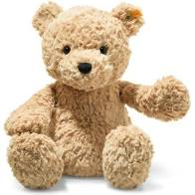
We actively encourage children to drink water throughout the school day. A drinking bottle (not glass) clearly marked with their name or a mark, which your child will recognise, is recommended. Children may refill their bottles from the classroom taps in school.
Toys and personal objects
Please do not send toys or personal objects to school. We are really lucky in that we have classrooms full of toys and fun things to learn and play with. We don’t want any special toys getting lost or broken. This includes pencil cases – all the stationery your child requires will be available in the classroom.

Supporting at home

Please do not be tempted to buy workbooks for your child to work through. There are lots of activities that you and your child can enjoy that will help develop all the skills they need and make their learning meaningful, practical and fun.

Many things you do at home will be helping your child to develop their skills. The list below is certainly not exhaustive but may give you some ideas or reassurance that you are supporting your child’s learning. Children all learn at different rates and it’s important not to compare. Your child will learn when they are ready and have the necessary experience and skills to build on.

Developing independence
Allow your child to have a go on their own and don’t be too quick to take over.

- Practise putting on their own clothes and shoes.
- Wash their hands after going to the toilet, before eating and after being outside.
- Use cutlery at mealtimes.
- Pour drinks and fill up their own water bottles.
- Tidy up after themselves.
- Open packets of snacks by themselves.
- Help you with tasks around the home.
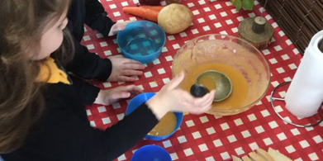
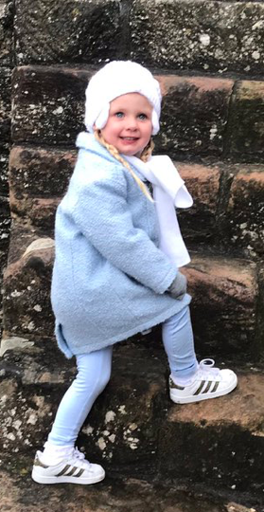

Supporting with health and wellbeing

- Talk to your child about what is going to happen. Go for a walk around the school and familiarise your child with the building. When we send out any transition information, share this with your child. Look through the school website and talk about what you see. The P1 twitter page will allow you and your child to see the learning in the P1 class so that you can talk with your child about what to expect.
- Listen to your child’s thoughts and feelings. Give your child plenty of space and time to talk about how they feel.
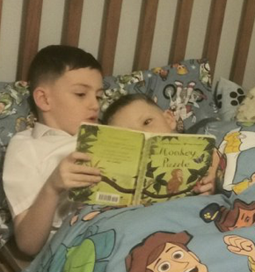
- Be creative and play. Giving your child time to play, allows them to process their experiences and feelings. Playing alongside your child allows you opportunities to further bond with your child.

- Take time to read books together. Children feel safe and happy snuggled up reading with someone they love.

- Take care of your own well-being. If you are relaxed and calm, these feeling will transfer to your child.

- Get outside! Playing outside is not only good for physical fitness, it also relieves stress and anxiety and can have a positive impact on self-esteem and mental health.

- Limit your child’s screen time to a maximum of an hour a day. Children will learn and thrive by having more broad and balanced play experiences.

- Try to get into a routine. Ensure your child has a good bedtime routine, including brushing teeth and reading a story before bed.

- Give your child praise and encouragement for their efforts – eg. showing kindness, helping out, tidying up. When things don’t go so well, try to be patient and support your child to find solutions themselves. Children are not trying to give you a hard time, but may be trying to communicate that they are not feeling OK at this time.

- Help your child to make choices by offering a choice of two things. “What do you want to do today?” is too big a choice and your child may end up disappointed. Instead offer two choices that you will be able to follow through with, “Would you like to go to the park or go for a cycle?” However, don’t feel pressure to always offer choices - children have also got to learn that sometimes there are no choices.

- Playing board games helps with learning about waiting and taking turns as well as developing concentration

Physical Development – gross motor skills

Encourage children to play indoors and outdoors with a range of materials to develop their motor skills. This is essential for children to develop the small muscles in their hands needed to write. Try:
- Catching and throwing to an adult or into a container using beanbags, different sized balls, scrunched up paper.
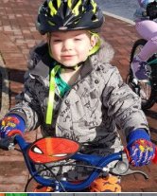
- Skittles – use empty food boxes.
- Kicking – a static ball, a moving ball.
- Balance on one leg and count
- Hopping – play Hopscotch
- Skipping without a rope – to music.
- Jumping from a height.
- Jumping forwards and backwards.
- Jumping over low objects.
- Walking backwards.
- Running round obstacles – make an obstacle course in the garden.
- Riding a bike
- Balancing while walking on planks of wood or walking on a line.
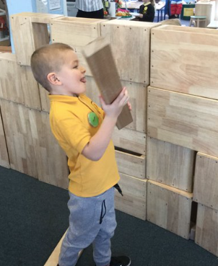
- Have fun at the park.
- Swimming
- Building with large objects
- Helping in the garden

Physical Development – fine motor skills
- Play dough – moulding, rolling etc.
- Threading – beads, pasta etc.
- Weaving
- Tearing paper – make a picture.
- Cutting and Sticking.
- Working with small construction
materials – Lego, building blocks
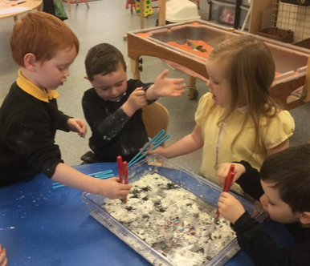
- Fastenings – buttons and zips.
- Drawing – people, shapes, lines

Maths Activities

- Explore shapes by using 3D objects (junk modelling or building blocks)
- Look for numbers, colours and shapes in the environment. Play I-Spy with colours and shapes.
- Set the table- matching and counting plates etc.
- Use teddies to play hide & seek games using position words – in, on, under, beside in front, behind, between, high and low.
- Build towers, make trains or play dough snakes and use measurement words – short, tall, big, small, long, thick, thin.
- Put toys in order of size.
- Count anything
- More or less – compare toys, buttons etc.
- Share out sweets or toys.
- Look for numbers on cars and doors.
- Complete a colour pattern using Lego, blocks or beads – red, blue, red, blue and so on.
- Time sequences – talk about your day – “After lunch we will go to the park then we’ll……! Talk about today, tomorrow, yesterday, before, after and next.
- Bake cakes or make play dough– lots of opportunities for counting and more, less, full, empty.
- Simple problems using toys or buttons – show me 3 cars, now make that 4 (or 1 or 2) adding on and taking away to get the number asked for.
- Sort the washing and put the socks into pairs.
- At the supermarket develop the understanding of colour, counting, size and talk about money.

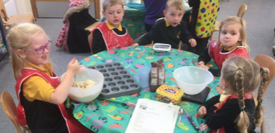

Literacy Development

- Encourage eye contact when talking.
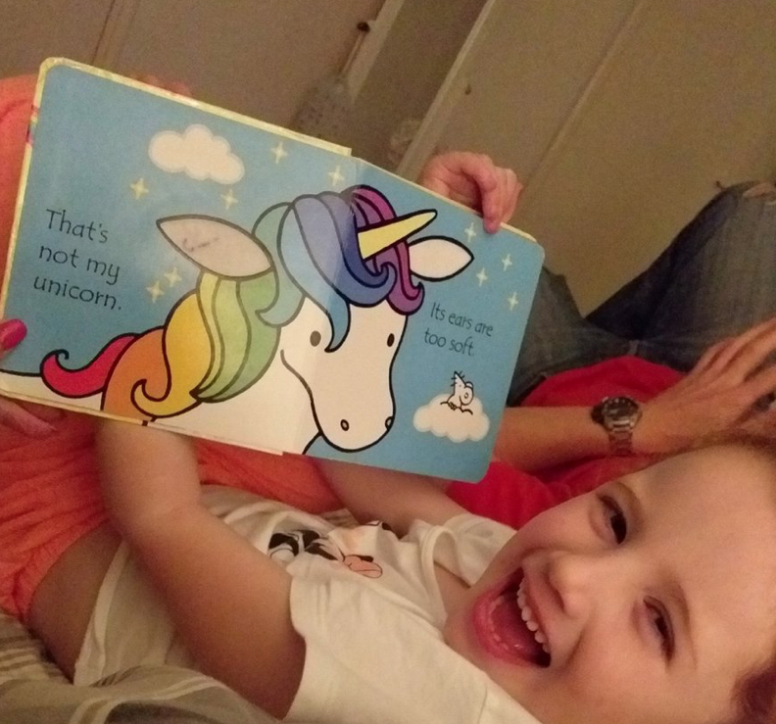
- Read books together. Use picture books to make up your own stories together. Talk about the pictures and the story.
- Say or sing Nursery Rhymes – play games and miss out words or say the wrong word.
- Read rhyming stories.
- Play rhyming games – fat, mat, sat.
- Re-tell favourite stories using the pictures as prompts or use puppets.
- Look for road signs, street signs.
- Play board games and snap.
- Play I-spy saying the letter sound rather than the name of the letter.
- Look for well-known shop signs, car logos etc.
- Find the letters in his/her name on signs, in books etc.
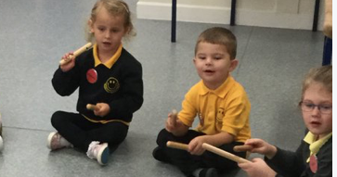
- Copy clapping patterns.
- Clap or tap out word patterns (syllables)
- Extend vocabulary by talking to your child. Use a mixture of familiar and unfamiliar words.
- Develop your child's language skills by playing alongside your child.
- Let your child see you reading and writing. Talk about what you are writing and provide opportunities for your child to explore using different writing materials.

