Primary 1 Home Learning Activities
Day 1
Literacy- Alphabet Hunt
Can you find a different item in your house/ garden for each letter of the alphabet? See if you can put them in order and practise writing the initial sound for each one like the example below.

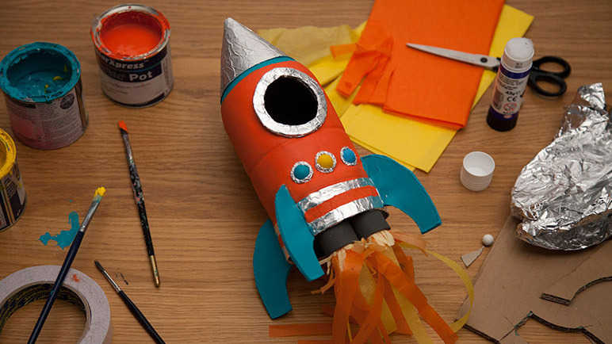
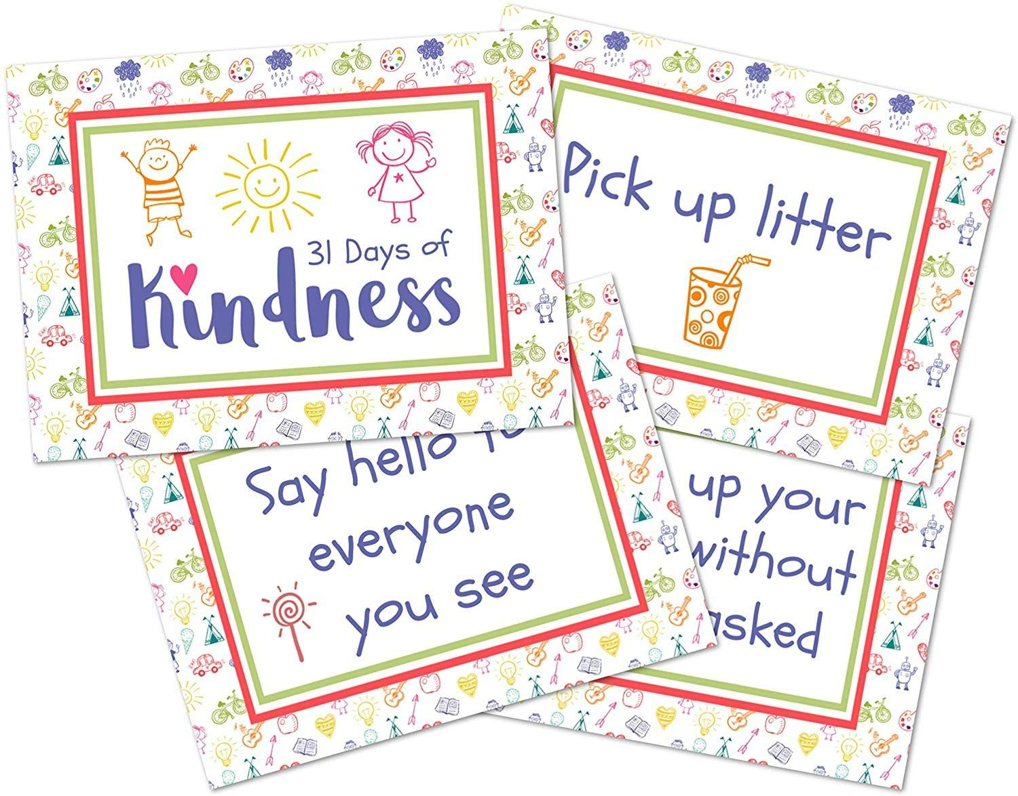
Health and Wellbeing – Acts of Kindness
Plan a secret kindness mission for someone in your home. Do something as a surprise to make them smile! Could you make a card? Help set the table for dinner? Draw a picture of what makes them a special person to you? How did they feel when you surprised them? How did it make you feel?

Maths- Shape Rockets
Make a model rocket from any items you have in your house. What shapes have you used? Are the 2D or 3D? How many of each shape are there?
Once complete stand it on the floor and start a countdown! Start at 10 or 20 and countdown to zero for blast-off! Then lift the rocket up for an adventure in space.

