Day 1 (22/02/21) | Day 2 (23/02/21) | Day 3 (24/02/21) | Day 4 (25/02/21) | Day 5 (26/02/21)
Literacy – daily tasks
Revise spelling words – see Teams
Access the ‘Epic’ online library at: Epic | The Leading Digital Library for Kids | Unlimited Access to 40,000 of the Best Children's Books & Learning Videos (getepic.com)
1. Select ‘log in’ 2. Select ‘students and educators’ 3. Enter class code: P6BS: vln9836 4. Find and select your name 5. Check your mailbox for assigned books
P6I: bcq3099
Literacy  Reading:  Access Epic! Using the instructions above.  Go to mailbox and look for Beyonce: R&B Superstar.  This is a ‘Read to me’ book, so turn your volume up and listen/read along.  When finished, take the quiz at the end.  Writing:  Apostrophes  Expand the contracted form of these words,  e.g. they’re – they are  you’re  I’m  we’re  she’s  you’ve  I’ve  it’s  they’ll  you’ve  we’ll  What other contracted words can you think of? | Literacy  Reading:  Access Epic! Using the instructions above.  Go to mailbox and find ‘Surfer Dog’. This is an audio book and so make sure your volume is turned up so that you can hear the story.  While listening, identify 5 main ideas from the story.  If you have forgotten how to find the main idea(s) of a text, this video link may help: Main Idea | Summarising | Reading Strategies - YouTube  Writing:  Suffixes  A suffix is added to the end of a word to make a new word.  For example: joy + ful = joyful  Write down (at least) three words to match each of the following suffixes:  -less  -ly  -er | Literacy  Reading:  Access Epic! Using the instructions above. Got to mailbox and find ‘The Classroom Zone’ and read it through.  Select a favourite joke and have a go at making up one of your own.  Writing:  Change and improve these sentences, making sure you keep the meaning.  Remember to use ambitious VCOP.  - the pirate stole the treasure  - there was an elephant at the zoo  - i saw a monster under the bed  - akbar sang a song at school  - i went to the scotland yesterday | Literacy  Please find live lesson at 10am and an assignment to complete on Teams. | Literacy  Please find live lesson at 10am and an assignment to complete on Teams.
Maths: Practise your Learn Its (See Teams)
Complete Home Learning Challenge on Sumdog
Numeracy  Please find live lesson at 10am and an assignment to complete on Teams. | Numeracy  Please find live lesson at 10am and an assignment to complete on Teams. | Numeracy  Please find live lesson at 10am and an assignment to complete on Teams. | Numeracy  Place Value  Write the numbers in ascending order (smallest to biggest):  - 30, 256, 87, 176, 68, 113  - 487, 378, 748, 225, 382, 477  - 956, 559, 658, 795, 612, 735  Do any of the number above have a 5 in them? Identify the value of the five in each number e.g. 5, 50, 500 etc | Numeracy  Sumdog Falkirk Contest starts today (26th Feb).  Log in and play for half an hour, at least.  Remember your target/maximum number of questions is 1000.
Active Learning Activities -
Please choose a task from the Project Sunshine Home Learning Grid
This can be found in the files section of Teams
Day 6 (01/03/21) | Day 7 (02/03/21) | Day 8 (03/03/21) | Day 9 (04/03/21) | Day 10 (05/03/21)
Literacy  Select 2 activities from World Book Day grid. This can be found in the Files section on Teams. | Literacy  Select 2 different activities from World Book Day grid. This can be found in the Files section on Teams. | Literacy  Select another 2 activities from World Book Day grid. This can be found in the Files section on Teams. | Literacy  Happy World Book Day! Please find live lesson at 10am and an assignment to complete on Teams. | Literacy  Please find live lesson at 10am and an assignment to complete on Teams.
Numeracy  Please find live lesson at 10am and an assignment to complete on Teams. | Numeracy  Please find live lesson at 10am and an assignment to complete on Teams. | Numeracy  Please find live lesson at 10am and an assignment to complete on Teams. | Numeracy  Last day of Sumdog Falkirk Contest today (4th March).  Log in and play for half an hour, at least.  Remember your target/maximum number of questions is 1000.  An you get our class higher up on the leader board? | Numeracy  Place Value  What are the values of the underlined numbers?
  889 | 165 | 422 | 821
  1595 | 2655 | 1101 | 7071
  8888 | 6707 | 6767 | 3121
Active/Outdoor Learning Activities  British Pie Week (1st Mar - 7th Mar) | Days Of The Year Can you head outside and make a mud pie? Remember flowers can be used too?  OR  Click on the link for other ideas. | Active Learning Activity - Art  Have a Google, then start a doodle in the style of …  Claude Monet  1840 – 1936  Famous Impressionist Artist  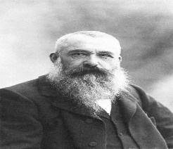  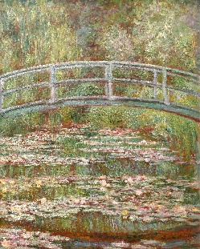 | Active Learning Activity - Art  Have a Google, then start a doodle in the style of …  Edgar Degas  1834 – 1917  Famous Impressionist Artist  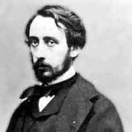  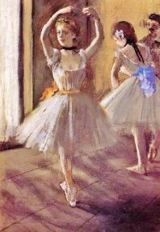 | World Book Day (Part 1)  Make us all smile and dress up as a book character. Alternatively you could use food to create a book character, e.g. paint/decorate a potato, an egg, etc.  Next, brush up on your children’s book knowledge for our Book Quiz at 2pm! | World Book Day (Part 2)  Work out the answers to the Children’s Books Emoji quiz! You will find this is in the Files folder on Teams. Then create 3 of your own using either emojis or pictures!

You can also find games, worksheets, videos and other resources at the following websites:
www.topmarks.co.uk
www.sumdog.com
www.primaryresources.co.uk
https://www.youtube.com/channel/UCt9SZgFExNwWTH5T_JnyF-A (maths songs)
https://www.youtube.com/channel/UCUNYSwNARexFwxXp3oPAtvg (Horrible Histories)
https://www.youtube.com/results?search_query=new+horizon+guided+meditation (mindfulness meditation)
https://www.bbc.co.uk/newsround/news/watch_newsround
www.mathsisfun.com
www.primaryhomeworkhelp.co.uk
www.tigtagworld.com
www.bbc.co.uk/bitesize

