First Level STEM home learning Grid:
Here are 5 STEM challenges for you to do at home.
If you are able to, tweet your STEM challenges through twitter using the tags @MpsStem and @RAiSE_falkirk You can also use the hashtag #maddistonstem

Colour wheel activity  You will need:  - Paper or card  - A sharp pencil  - Colouring pens or pencils  - Cocktail sticks (optional)  - Scissors  Here is a link to video on how to make it:  https://www.youtube.com/watch?v=CU2xfMV6nOE  Although the clip shows cocktail sticks, you can still make your wheel without and spin it on a flat surface to see how the colours blend!  When creating your wheel, have a think about what colours you are using. You could create a rainbow effect, or a pattern by using alternating colours e.g., red, blue, red, blue.  Think about what new colours you could make by using different combinations!  What happens when you use all of the colours you can find?  What colours work better together than others? | 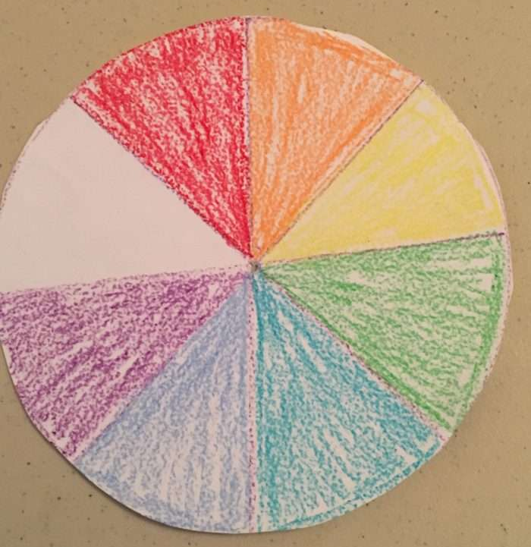
Magic pepper trick  -Ask an adult’s permission first-  You will need:  - A plate or bowl with some water in it  - Pepper  - Washing up liquid  - A towel for any mess  Watch the following clip to show you what to do.  https://www.youtube.com/watch?v=DGaLC4XBGo8&t=3s  The video also asks further investigation questions to get you thinking! | 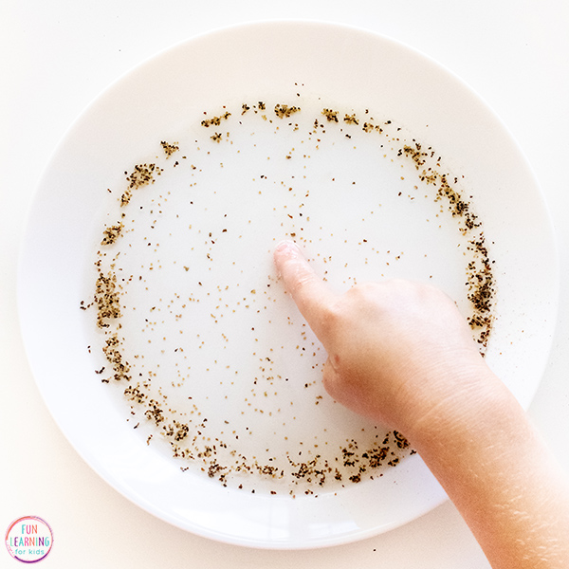
Shape Strength  You will need: ·  - A4 paper  - Sticky tape/quick dry glue  - Piles of book/magazines/flat objects for weight  1. Begin by folding A4 paper into three columns with different shaped bases: square, triangular and circular. Use sticky tape to hold each column together.  2. Which column do you think will hold the greatest weight? Why?  3. Test one of the columns by slowly stacking books on top of it. Count how many books it can hold before it collapses.  4. Repeat with the second and then third column.  5. Which shape held more books? Why do you think this was? | 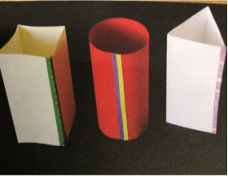
Nature walk  Go for a walk with your family and hunt for plants!  Can you find the following things?  •A plant with leaves that aren’t green?  •A plant growing somewhere unusual, for example in a crack in the pavement or the walls of a house?  •A plant that is taller than you?  •A plant with flowers that are more than one colour?  •A plant with spiky leaves?  •A plant that smells nice?  •A plant that bees like?  Record what you find when on your walk and make a poster showing all the plants you found! | 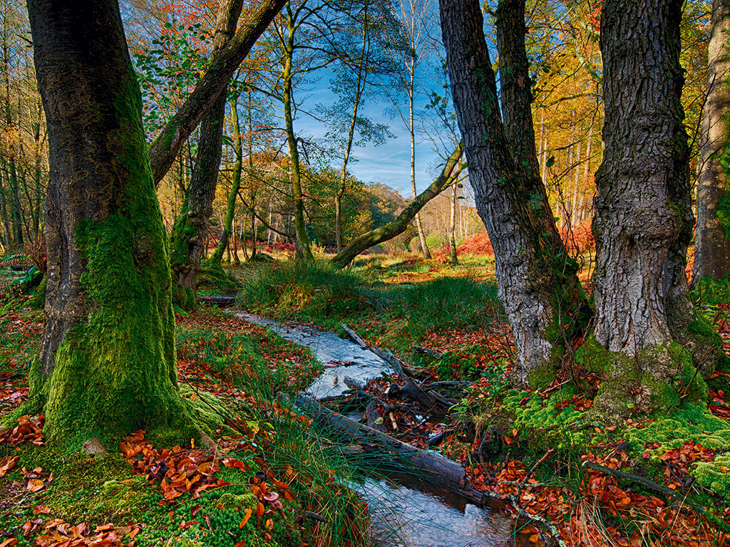
-requires adult supervision-  Making a boat for your toy!  Using recycled materials such as cardboard, plastic bottles and tinfoil, build a boat and test it in water!  Have a think about how big your boat should be, and what material works best. E.g. plastic or paper?  Once you have made your boat and it is on the water, place one of your toys inside it and see if it sinks!  If it sinks, have a think about why it has sunk and what you could do to make it better.  Here is a follow up video (copy and paste into google) which will help you understand why your boat sank or stayed afloat!  https://www.youtube.com/watch?v=2dyCe1GPagE | 