25th January Monday | Tuesday | Wednesday | Thursday | Friday
Numeracy - Doubles  Roll either 1 or 2 dice and double the number.  Sing along to your double with:  https://www.youtube.com/watch?v=8jOzhiACB68  Practise doubles and 2x table using:  Hit the Button - Quick fire maths practice for 5-11 year olds (topmarks.co.uk) | Literacy  Read a text of your choice for at least 10 minutes. This could be Bug Club, Borrow Box, Oxford Owl or a book/comic in your house.  Draw 4 pictures of words containing your sound.  Medium – ey as in monkey  Mild – ll as in ball | Numeracy - 5 times table  Draw around your hand 10 times. On one side of each hand write the multiples of 5 and on the back of the hand write the question. Use them to practise your stations of the 5 times table.  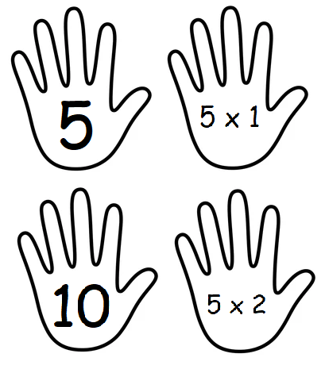 | Literacy  Read a text of your choice for at least 10 minutes. This could be Bug Club, Borrow Box, Oxford Owl or a book/comic in your house.  Spelling words –  Medium - read, call, even, close  Mild – for, are  Write them using rainbow writing.  Write a sentence for each word – remember to use a capital letter and a full stop.  Hot – use an interesting opener, adjective, interesting verb or conjunction to uplevel your sentence | Numeracy - 10 times table  Write out the questions of your 10 times table and time how quickly you can write the answers.  Ask someone in your house to quiz you with the questions out of order.
Scottish Week  Ask an adult in your house what their favourite thing about Scotland is. | Scottish Week - Art  Create a Scottish flag (Saltire) out of materials in your house. | Health and Wellbeing  Take part in a Cosmic Kids Yoga workout to get your body moving. They are available on YouTube or on the Cosmic Kids website. | Scottish Week - Music  Listen to some Scottish bands.  Some suggestions – The Proclaimers, Deacon Blue, Runrig. | Scottish Week  What do you really like about Scotland?  Draw a picture to show all your favourite things about living in Scotland.
1st February Monday | Tuesday | Wednesday | Thursday | Friday
Numeracy  Create a times table poster to hang on your bedroom wall. Choose one of the times tables below:  2, 4, 5 or 10 | Literacy  Read a text of your choice for at least 10 minutes. This could be Bug Club, Borrow Box, Oxford Owl or a book/comic in your house.  Draw 4 pictures of words containing your sound.  Medium– ie as in field  Mild – sh as in shed | Numeracy  Collect 40 small objects from around your house e.g. pasta, buttons, small cars or Lego and sort them into groups of 4.  Practise sharing them out equally for all multiples of the 4 times table.  E.g. 3 x 4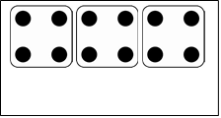 | Literacy  Read a text of your choice for at least 10 minutes. This could be Bug Club, Borrow Box, Oxford Owl or a book/comic in your house.  Spelling words –  Medium - begin, often, follow, letter  Mild – as, with  Write them using bubble writing.  Write a sentence for each word – remember to use a capital letter and a full stop.  Hot: use an interesting opener, adjective, interesting verb or conjunction to uplevel your sentence | Numeracy  Sumdog class competition – times tables
Life Skills  Help to make a slice of toast or sandwich for one of your meals today. Practise spreading the butter/ jam smoothly with a knife. | PE  Create your own exercise routine or take part in a Joe Wicks workout. Remember children need to get one hour of moderate physical activity per day.  https://www.youtube.com/channel/UCAxW1XT0iEJo0TYlRfn6rYQ | IDL – Castles  Find out about a Motte and Bailey castle then draw and label a diagram to show what you discovered. | Music  Play along with the game on the link below.  https://www.bbc.co.uk/teach/bring-the-noise/eyfs-ks1-music-play-it-bring-the-noise/z4sq92p | Art - Draw with Rob  Follow the step by step instructions in the video below to create your very own monster character.  https://youtu.be/PedfXGus_K0

