Inside Out Emotions Task

DISGUST

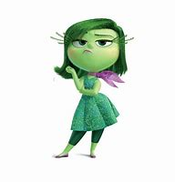

Using A4 paper, draw your own picture of Disgust.
You can use ‘Art for Kids Hub’ on YouTube to help:
https://www.youtube.com/watch?v=NI3fkfka8LQ

On the other side, or another piece of A4 piece of paper, fold it in half and draw lines...
- 3

2

Section 1 - write a list of behaviours you might display/what you might look like if you are feeling this emotion.
Section 2 - write a list of other words that could mean the same.
Section 3 - write about a time when you felt this way.

Please share your artwork and activities with me on twitter @TheSunStation2

