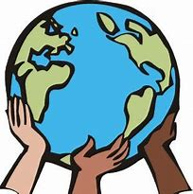
If I ruled the world…
Write or draw what your world would look like, feel like and be like if you ruled the world.
Who would live there?
What rules would there be?
What type of leader would you be?

